CSA1523- CLOUD COMPUTING AND BIG DATA ANALYTICS FOR HEALTH CARE INDUSTRIES

EXP NO 1: CREATE A SIMPLE CLOUD SOFTWARE APPLICATION AND PROVIDE IT AS A SERVICE USING ANY CLOUD SERVICE PROVIDER TO DEMONSTRATE SOFTWARE AS A SERVICE (SAAS).
AIM:
To Create a simple cloud software application and provide it as a service using any Cloud Service Provider to demonstrate Software as a Service (SaaS).
PROCEDURE:
STEP 1: Log in to ZOHO Creators
STEP 2:Click Create a new application.
STEP 3: Choose from scratch and name the application (Ex-Hospital App)
STEP 4: Create a new form as per the requirements. (Ex- Patient , Doctor , Billing , Test results etc)
STEP 5: Drag and place the required fields and click DONE.
STEP 6: Now open each module and give required details to store it in the form.
STEP 7: Verify the entries of patient details, doctor details, etc from Reports.
STEP 8: The software has been created successfully.

IMPLEMENTATION:
STEP1: Login to ZOHO Creators
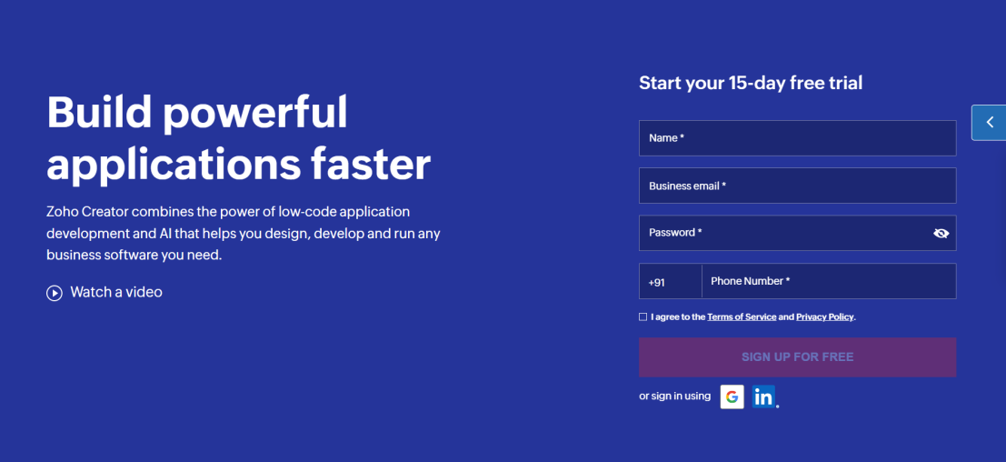
STEP 2:Click Create a new application.
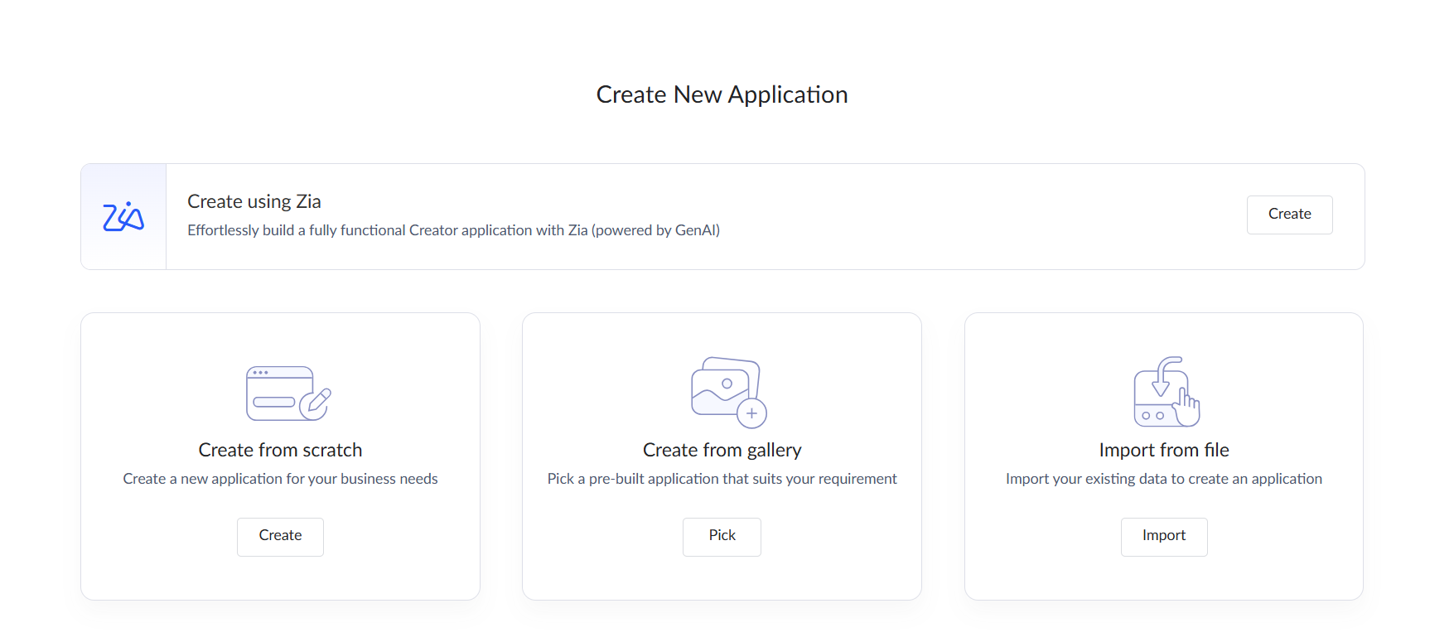
STEP 3: Choose from scratch and name the application (Ex-Hospital App)
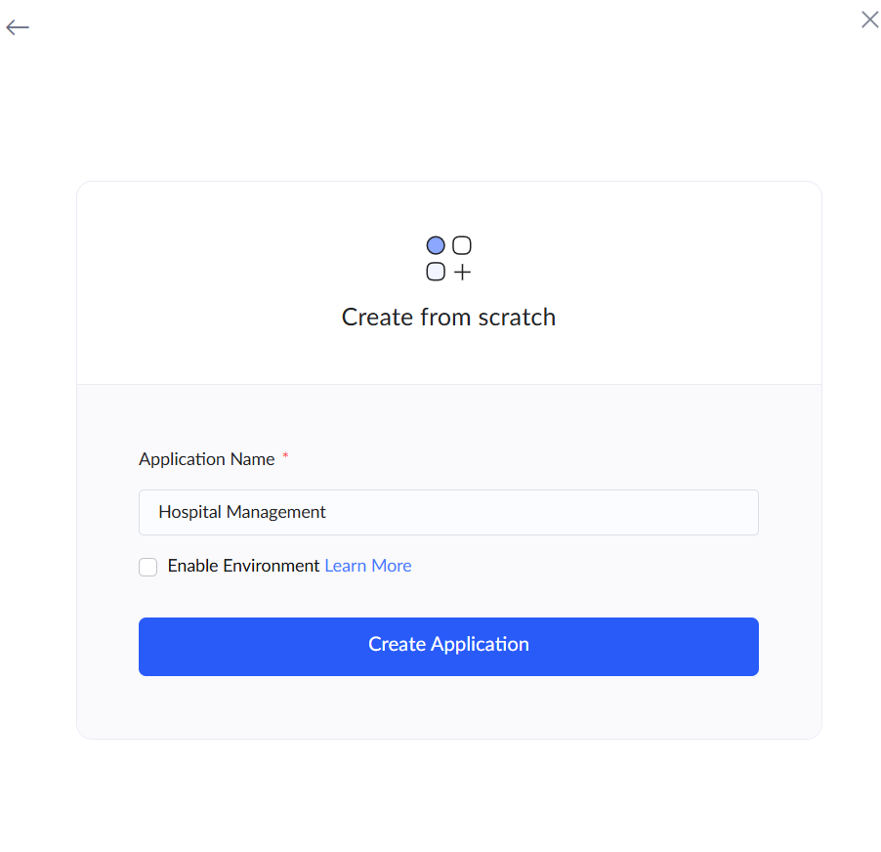
STEP 4: Create a new form as per the requirements. (Ex- Patient module, Doctor module,
Appointments, Billing , Test Results etc)

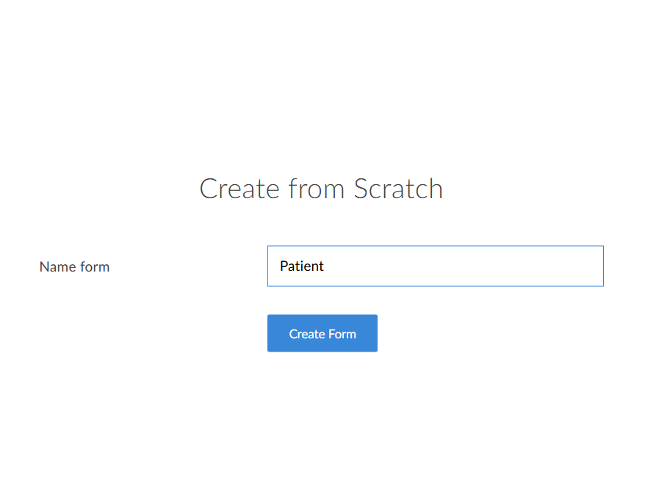
STEP 5: Drag and place the required fields and click DONE

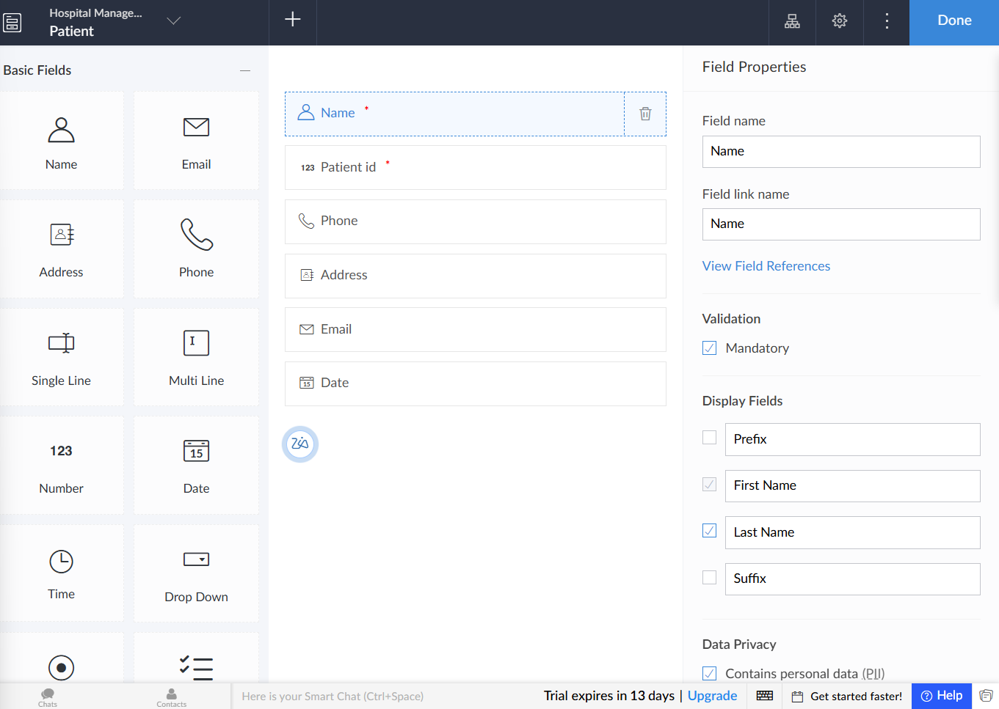

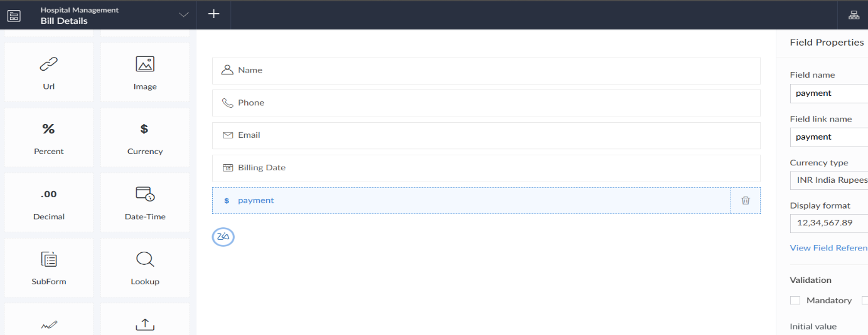

STEP 6: Now open each Form and give required details to store it in the form.
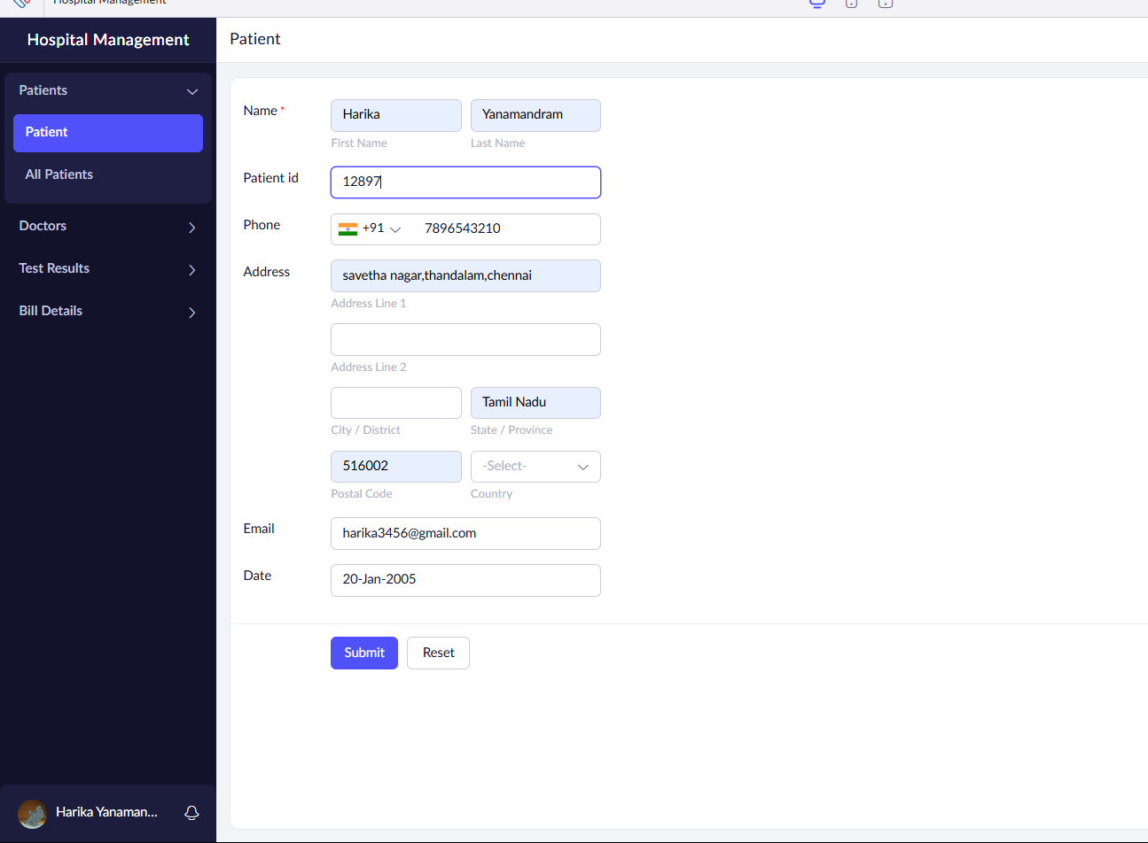

STEP 7: Verify the entries of patient details, doctor details, etc from Forms.
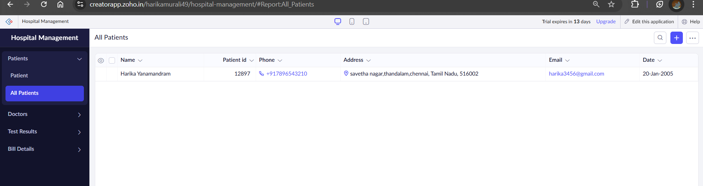

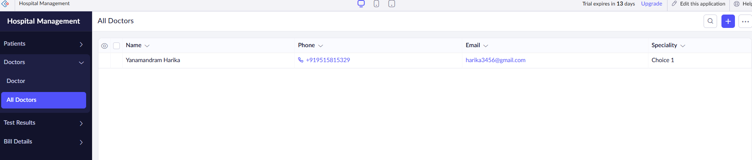
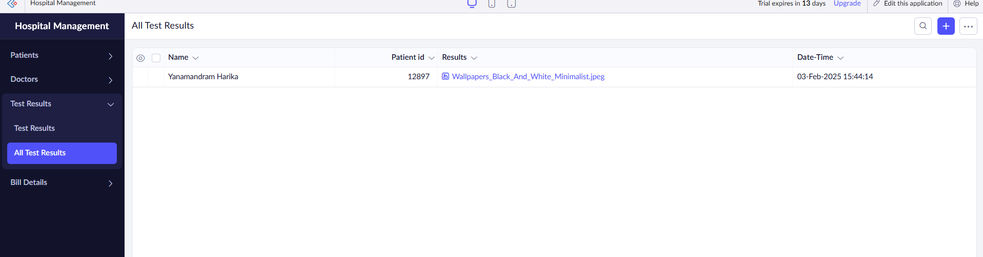

The software has been created successfully.

